Topics for discussion at June 2016 Laboratory LOINC Committee meeting

Proposed standard model for LOINC order codes for genetics (D Vreeman, S Abhyankar, J Deckard)

Issue 1
Different labs want different codes for reporting the same set of results. For example, we get requests for document-level codes for representing the report as a whole, nominal codes to report the variant found, ordinal codes to report the presence or absence of a particular variant, and impression codes for reporting the overall impression.
Some users use the Prid/Nar codes for reporting impressions, others use them for the overall report. The same test could potentially be represented in LOINC in many different ways, which does not make sense for interoperability and is not a sustainable model.
We need a standard model for creating LOINC genetics order codes.

Proposals
- Create Find/Doc codes that can be used to order a specific study and to carry the overall result report.
- Use the genetics observation panels created for HL7 v2 messaging as associated observations attached to each of the Find/Doc codes to report the discrete, coded results
- Create a new set of Find/Doc codes to correspond to all of the existing Prid/Nar terms, since Prid/Nar codes are being used to report the impression by some users.

Supporters
To date we have gotten support for the above model from Bitac, Baylor College of Medical Genetics, and Kaiser Permanente
Kaiser Permanente HealthConnect
“Discussing this proposal with our lab terminology group the feeling was that this approach would be consistent with how we are currently mapping other complex reports in terms of using generic interpretations and thus we would support it.”
“Genetics and the KP regional lab in SCAL are OK with using generic LOINC codes for genetic test interpretations.”
Bitac
“Bitac completely supports this approach. We think that Find/Doc codes will be useful in our real scenario about Genetic reports.”

Examples
Specific order & report code:
81851-8 Chromosome region 11p15 methylation & deletion+​duplication: Find: Pt: Bld/​Tiss: Doc: Molgen

NAME
Potential codes:
51967-8 Genetic disease assessed [ID]
53577-3 Reason for study additional note [Text]
Potential codes:
48004-6 DNA sequence variation
51968-6 Genetic disease analysis overall interpretation
Potential codes:
77202-0 Laboratory comment
62366-0 Recommended action [Identifier]

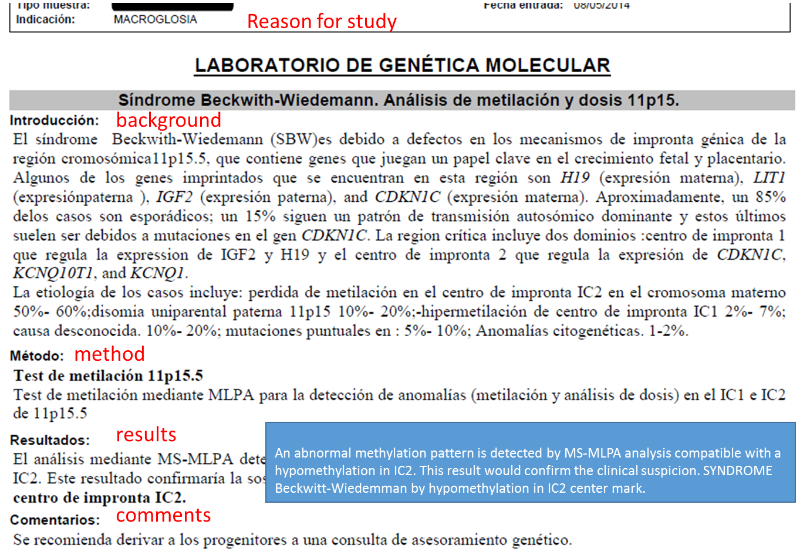

Specific order & report code:
xxxxx-x Leukemia mutation analysis: Find: Pt: Bld/​Tiss: Doc: Sequencing
Potential codes:
51968-6 Genetic disease analysis overall interpretation
48018-6 Gene identifier [ID]

Long Common Name: Gene [Identifier] in Blood or Tissue
Shortname: Gene ID Bld/T

Potential codes:
48004-6 DNA sequence variation
48005-3 Amino acid change

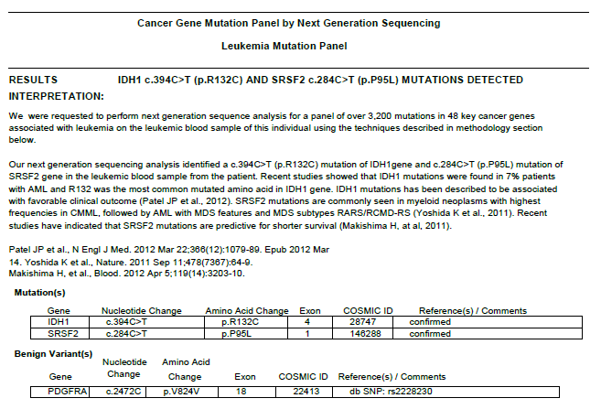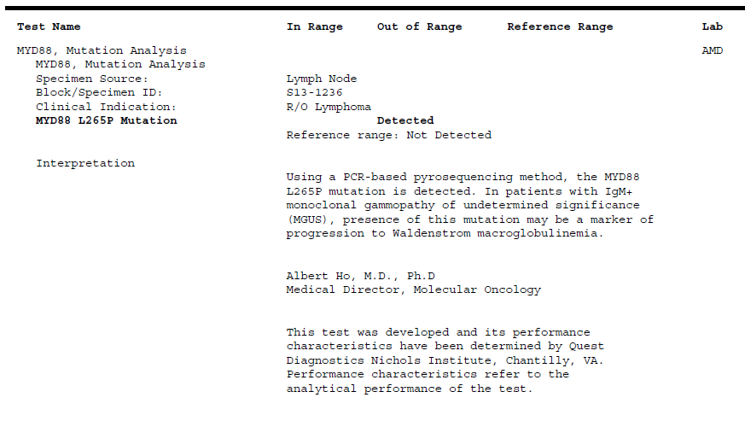
Potential codes:
77202-0 Laboratory comment
81255-2 dbSNP [Identifier]

81256-0 COSMIC [Identifier]
48001-2 Chromosome region
48005-3 Amino acid change

NAME
Fully-Specified Name: Component Property Time System Scale Method
Amino acid change Find Pt Bld/Tiss Nom Molgen

Long Common Name: Gene [Identifier] in Blood or Tissue
Shortname: Gene ID Bld/T

48004-6 DNA sequence variation

Long Common Name: Gene [Identifier] in Blood or Tissue
Shortname: Gene ID Bld/T

Specific order & report code:
81851-8 MYD88 gene.p.Leu265Pro mutation analysis: Find: Pt: Bld/Tiss: Doc: Molgen

NAME
Potential codes:
51967-8 Genetic disease assessed [ID]
53577-3 Reason for study additional note [Text]

Generic result/interpretation code:
51968-6 Genetic disease analysis overall interpretation

Specific order & report code:
xxxxx-x AXIN2 ful gene mutation analysis: Find: Pt: Bld/​Tiss: Doc: Molgen

NAME
Potential codes:
51967-8 Genetic disease assessed [ID]
53577-3 Reason for study additional note [Text]
Potential codes:
51968-6 Genetic disease analysis overall interpretation
77202-0 Laboratory comment
62366-0 Recommended action

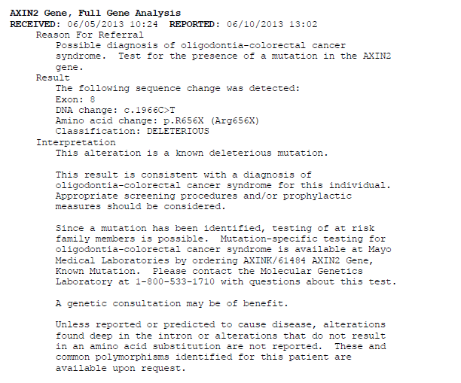
53037-8 Genetic disease sequence variation interpretation
48001-2 Chromosome region
48004-6 DNA sequence variation

Long Common Name: Gene [Identifier] in Blood or Tissue
Shortname: Gene ID Bld/T

48005-3 Amino acid change

NAME
Fully-Specified Name: Component Property Time System Scale Method
Amino acid change Find Pt Bld/Tiss Nom Molgen

Long Common Name: Gene [Identifier] in Blood or Tissue
Shortname: Gene ID Bld/T

Issue 2
LOINC has four primary types of mutation analysis codes: 1. Full gene mutation analysis; 2. Targeted mutation analysis; 3. Analysis limited to known familial mutations; and 4. Specific codes for individual named mutations.
Targeted mutation analysis codes represent assays that look for a specific set of mutations, and is defined as such in the LOINC user guide, but (unfortunately), the Component doesn’t specifically say that.

Proposal
Change the Component for all of the targeted mutation analysis codes to specifically say “CYP11B1 gene targeted mutation analysis”

Discussion about re-naming EIA to IA (D Vreeman, S Abhyankar)

Issue 1
Confusion about the Method “EIA” (aka “a case of unfortunate naming”). The “EIA” method was always intended to cover more than just enzyme-linked immunoassay and was just a convenient shorthand. The display name for the long common name has always been “Immunoassay.”
Explanation regarding EIA in the LOINC user guide:
Immune assays in the LOINC world include a large swath of tests. We have historically lumped together immune assays that detect the linking of antigens and antibodies via special signaling mechanisms, such as EIA, ELISA, chemiluminescence and other similar tests that produce one measure (quantitative or qualitative) of the analyte of interest. We thought of this class of tests as “EIA-like” and in the absence of an existing short acronym to describe their constituents, we borrowed “EIA” to provide this meaning in the Short Name and used Immunoassay in the Long Common Name to signal that this method type was not limited to pure EIA tests. Going forward we will try to come up with a more evocative name for what we mean. Note that some immune fluorescent tests, done on serum for example, would fit our definition in terms of detecting the linking of antigens and antibodies, but we have not lumped them into our general EIA-Immune assay category because many also provide information about location as well as presence or amount. Users of LOINC have been satisfied with our approach.

Proposal
Change the Method name from “EIA” to “IA” and “EIA.rapid” to “IA.rapid”

Issue 2
Historically, all immunofluorescence tests have had the method “IF”. Excerpt from LOINC user guide:
IF… can provide information about the presence or amount of a target analyte and its location on a smear, tissue slice or cell (though all IF tests do not provide such location information)
Most likely, tests with the System ser/plas only provide information about presence/amount of the analyte and not its location.

Proposal
Going forward, use method “IA” for ser/plas immunofluorescence terms.
Consider reviewing existing IF codes (~850) to see if could be changed to IA.

Discussion about consolidating ACnc, Presence and Threshold (D Vreeman, S Abhyankar)

Issue
Historically, ACnc was used as a placeholder for the Property of Ordinal codes. A few years ago,
we started transitioning to “Pr” as the Property for observations reported simply based on whether the analyte is present or not without being determined by a cut off value, and “Threshold” as the property for observations reported as “positive” or “negative” based on an internal threshold or cut off.

Currently, about 5000 codes with either the “Pr” or “Threshold” Property (probably ~1/3 of those are codes created after the ACnc -> Pr/Threshold change). Still have about 7000 ACnc/Ord codes. As it turns out, it is very difficult to figure out whether an existing ACnc code should have the Property Pr versus Threshold, and even for new codes, the distinction is not always easy.

Also, all else being the same, our policy has been to create ONLY a Pr or Threshold code, but not both, because the result has the same meaning. So in cases where there are two assays where one could potentially have the Property Pr and the other Threshold, most likely users will map both to whichever code is available, which is most likely based on who requested the code first.
Examples
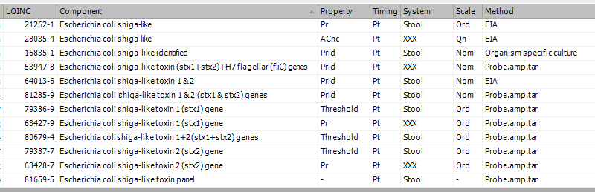

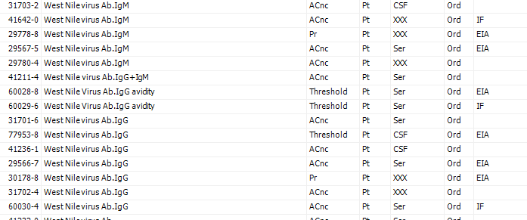

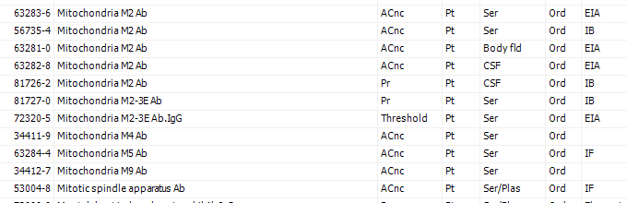

Proposal
Consolidate the ACnc, Pr and Threshold properties into a single “PrThr” Property.
Update all of the codes that have an Ordinal Scale and any of these three Properties to have the PrThr Property, deprecate duplicates that would be created as a result of this change.

Probe.amp.tar v non-probe based PCR methods (S Abhyankar, J Yao)

Issue
Historically, we have had three Methods for various probe-based PCR methods:
1. Probe without amplification (Probe)
2. Probe with target amplification (Probe.amp.tar)
3. Probe with signal amplification (Probe.amp.sig)

In another case of misfortunate naming, the abbreviation of the “Probe.amp.tar” Method is “PCR”, even though PCR is a more general concept.

Last fall, we began working on a series of micro assays that are done by PCR, followed by melt curve analysis to identify the organism that was found. We spoke to the manufacturer, and neither of us thought “Probe.amp.tar” would be correct because no probe is used.

The LOINC team decided to create a new Method called “melt.amp.tar”, and 5 terms with that method were released in December 2015:

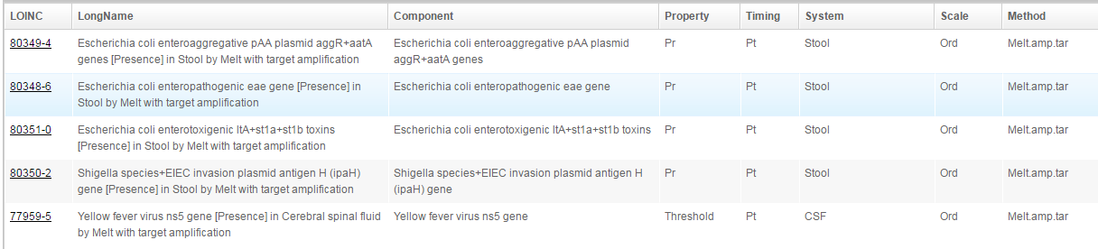

However, after the December 2015 release, we had further discussion with the manufacturer and Dr. Yao about creating a Method that includes all non-probe based methods, not just melt curve analysis.

Proposal
Create a new Method called “Non-probe.amp.tar”, update the five terms that currently have the “Melt.amp.tar” Method, and moving forward, use “Non-probe.amp.tar” for melt curve and other methods that are based on something other than a probe to identify the substance found.

User-friendly long and short names (D Vreeman)

Issue
We have been thinking about different ways to create more friendly long and short names. We have updated some names, esp in the Coag class, and for new terms are trying to make them shorter/simpler, but have not implemented any systematic changes.
We received input from a subgroup of the S&I Framework Lab Orders group (including several Committee members) for creating common names using a set of rules that could potentially be incorporated into the LOINC db. Upon preliminary review, we found rules and proposed acronyms/abbreviations that we are already implementing and some that are straightforward and we will implement, as well as some we would like to discuss with this Committee.

Discussion

Proposed rules
Rule type | Rules | Examples
ANALYTE | 1. The identifier of the substance (analyte) being measured must come first.  2. Use the more common name rather than scientific name where possible, except as tradition dictates or clinical experts believe it is required to avoid confusion.  3. Do not use double names, pick only one name for the analyte.  4. First letter of a test name shall be upper case, use mixed case.
QUALIFIERS | 1. specimen type - use abbreviation and put in ()  2. specimen number - do not number 1; use # numbers  3. time period -use analyte h or m  4. organism - use (n) | 1. (U)  2. analyte #2  3. Glucose 90m  4. Organism (3)
RATIO | Use “:” should not use / or “ratio”
STRAINS OF HPV | 1. Do not recommend including the strain number(s) in the name of HPV tests -- but should include “hi risk” and “low risk” on the name for the test (HPV hi risk, HPV low risk) DO NOT USE hr-hpv OR lr-HPV  2. should discourage low risk testing
TIME | 1. If collection is for 24 hours - express as mass 24h  2. If collection is less than 24 hours -use / to indicate calculated value is extrapolated for 24 hours from actual value  3. Only report AM, not PM  4. Sequence of timed studied reported as Glucose 90m, Glucose 120m, Glucose Fasting 12h  5. 24h is assumed to be Urine, so the (U) is not required. Other specimen types must include specimen type. | 1. Calcium24h  2. Calcium/24h  3. Cortisol AM  "
METHOD | 1 Include method only when it is clinically relevant (e.g. following tumor markers) to the interpretation of the result – what about new test methods (e.g. APS) – need process to manage  i. HPV today by DOM (not included in name)  ii. New method for HPV FNM (that is clinically relevant to the interpretation of the result)  iii. Change HPV to HPV DOM and use new method as HPV FNM  2. . Use abbreviation listed under tab Methods. | See below

Method abbreviations
Method | Abbreviation | Current LOINC abbreviation
Biopsy | BX | n/a (not a lab method)
Complement Fixation | CF
Culture | CULT
Immunoassay | IA | ?
Immunoblot (Western Blot) | IB
Immunostain | IS | ImStn
Ink Prep | Ink Prep | India ink prep
Nucleic Acid Amplification Test | NAAT | -
Polymerase Chain Reaction | PCR | -
Wet Prep | WP | Wet prep
Western Blot | WB | (part of IB)

Sample specimen abbreviations
Serum | S
Serum/Plasma | S/P
Serum/Plasma/Blood | S/P/B
Skin | Skin
Sputum | Spu
Synovial Fluid | SnvFl
Throat | Th
Tissue | Tiss
Urethra | Uret
Urine | U
Vaginal | Vag
Vaginal Fluid | Vag Fl
Vaginal/Rectal | VagRec

Examples of duplicate proposed short/long names if leave off Prop/Method:
LOINC NUM | LOINC_LCN | Proposed Long Name | Proposed Long Name + System if required | Proposed Short Name
1751-7 | Albumin [Mass/volume] in Serum or Plasma | Albumin | Albumin (S/P) | Alb
14957-5 | Microalbumin [Mass/volume] in Urine | Albumin | Albumin (U) | Albumin
2862-1 | Albumin [Mass/volume] in Serum or Plasma by Electrophoresis | Albumin | Albumin (S/P) | Albumin
13992-3 | Albumin/Protein.total in Urine by Electrophoresis | Albumin % | Albumin % (U) | Albumin %
17819-4 | Albumin/Protein.total in unspecified time Urine by Electrophoresis | Albumin % | Albumin % (U) | Albumin
13986-5 | Albumin/Protein.total in 24 hour Urine by Electrophoresis | Albumin % 24h | Albumin % 24h (U) | Albumin %
1746-7 | Albumin [Mass/volume] in Cerebral spinal fluid | Albumin (CSF) | Albumin (CSF) | Albumin
1747-5 | Albumin [Mass/volume] in Body fluid | Albumin (Fld) | Albumin (B Fl) | Albumin
6942-7 | Albumin [Mass/volume] in Urine by Electrophoresis | Albumin | Albumin (U) | Albumin
5273-8 | Parvovirus B19 IgG Ab [Units/volume] in Serum by Immunoassay | Parvovirus B19 IgG | Parvovirus B19 IgG (S) | Parvo B19 IgG
7983-0 | Parvovirus B19 IgG Ab [Units/volume] in Serum | Parvovirus B19 IgG | Parvovirus B19 IgG (S) | Parvo B19 IgG
25630-5 | Parvovirus B19 IgG Ab [Titer] in Serum | Parvovirus B19 IgG | Parvovirus B19 IgG (S) | B19V IgG Titer
29675-6 | Parvovirus B19 IgG Ab [Presence] in Serum | Parvovirus B19 IgG | Parvovirus B19 IgG (S) | PVV 19 IgG
29660-8 | Parvovirus B19 IgG Ab [Presence] in Serum by Immunoassay | Parvovirus B19 IgG | Parvovirus B19 IgG (S) | PVV 19 IgG
5274-6 | Parvovirus B19 IgM Ab [Units/volume] in Serum by Immunoassay | Parvovirus B19 IgM | Parvovirus B19 IgM (S) | Parvo B19 IgM
7984-8 | Parvovirus B19 IgM Ab [Units/volume] in Serum | Parvovirus B19 IgM | Parvovirus B19 IgM (S) | Parvo 19 IgM
40658-7 | Parvovirus B19 IgM Ab [Presence] in Serum by Immunoassay | Parvovirus B19 IgM | Parvovirus B19 IgM (S) | PVV 19 IgM
7981-4 | Parvovirus B19 IgM Ab [Presence] in Serum | Parvovirus B19 IgM | Parvovirus B19 IgM (S) | PVV 19 IgM

Discussion regarding use cases and guidelines for creating and modifying laboratory panels (S Abhyankar, J Deckard) [ONLINE HANDOUT]

Issue
We have been receiving many more laboratory panel requests over time and need to develop guidelines around when to create new panels and when to modify existing panels. Issues include whether we can add new terms to existing panels and cardinality of individual codes within a panel.

Variety of use cases for panels, including:
- Specific orderable – the panel code is the order code, can specify which elements are required, optional etc.
- Menu for ordering – the panel provides a list of tests that are orderable (all optional), and the provider or laboratory can pick which ones to use for the specific patient or context
- Generic order code – the panel code is implemented as a generic orderable (e.g., stool culture or respiratory culture), and the laboratory performs the tests according to the kits/instruments currently available in that laboratory
- Group all of the terms in a specific test kit together – this use case could overlap with both 1 and 2 above, depending on whether the kit has individual orderable components

Examples

Model 1
We have several different panels for various respiratory pathogens named for how many children are in the panel, which were created based on specific test kits. Most of these don’t have any conditionality specified.
Pros – can be used as specific orderables, can keep track of which panel is used for which kit
Cons – explosion of panels, redundancy, difficult to maintain over time, when a particular hospital or laboratory implements a new test kit, will have to update the order code, when a kit manufacturer adds or deletes an element, will have to request new code and update the panel code
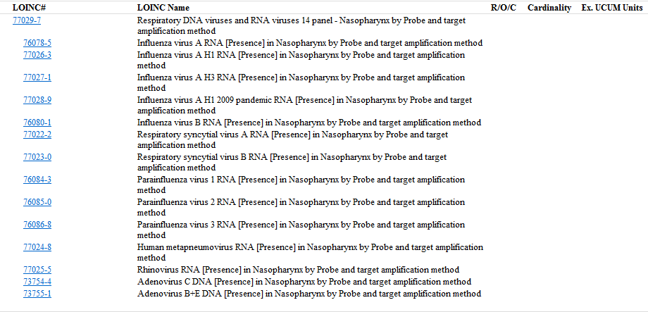
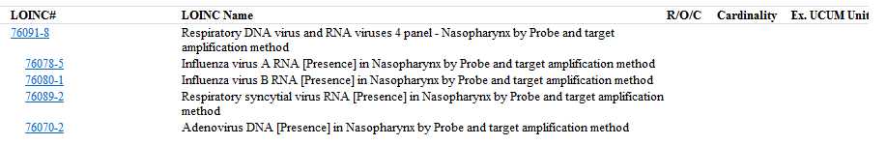

Model 2
The enteric pathogens panel was originally created for a specific manufacturer’s test kit. We received another request for an enteric panel that created many of the same terms as the original panel. We decided to add the extra terms from the new request to the same panel, and in the term description we included the list of codes in each kit. Conditionality is not specified.
Pros – easy to maintain, limits the number of codes, instrument manufacturers wouldn’t have to update their panel codes every time the elements of the panel change, laboratories wouldn’t have to change their order codes (depending on how the panel code is implemented)
Cons – cannot be used as specific orderable, won’t know which terms were in which panel unless we keep track of them in the term description or elsewhere
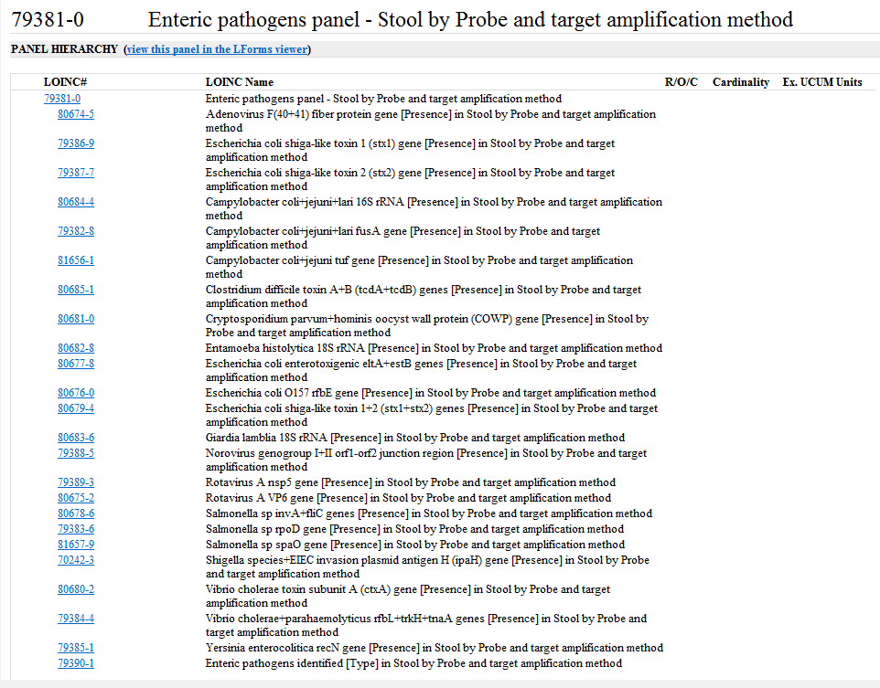

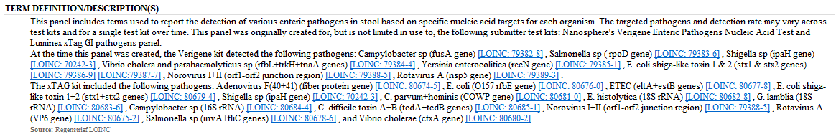

Model 3
Panels where specific children are designated as required, optional, conditional
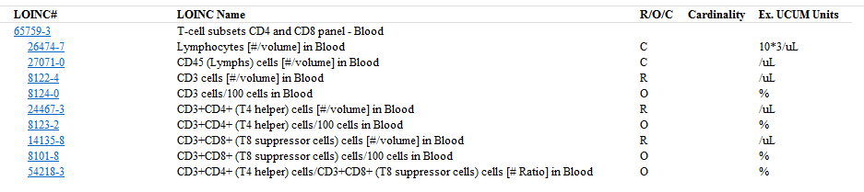

Model 4
We have a few panels named for the year they were specified by CMS. All elements have conditionality per CMS.
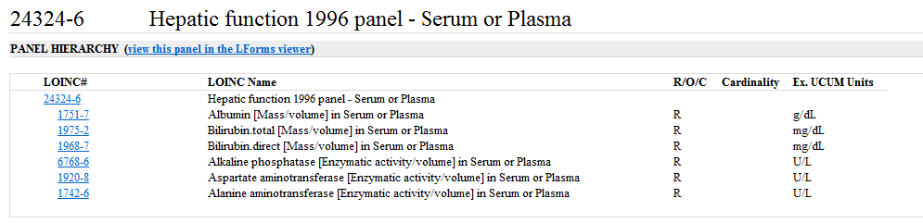

Questions – need instrument/lab kit manufacturer, hospital, laboratory input
1. Should we create different panels for different test kits or create more generic panels that are kit-agnostic?
2. If we make kit-specific panels, what happens when a new analyte is added or removed in the next version of the kit? Do we add to the existing panel or create a new one? If we create a new panel, do we discourage the old one or do we keep it for people who are still using the older version of the kit?
3. Should we create specific orderable panels with different (but similar) groups of terms for different hospitals/laboratories? If yes, what happens when the orderable panel changes – do we update the panel or make a new one?
4. Conditionality - Many (most?) of our panels do not have any conditionality specified. Should we be assigning conditionality based on a single submitter or do there have to be some sort of clinical guidelines or formal recommendation before we assign conditionality (e.g., the lupus anticoagulant algorithm), especially because conditionality assignment has a big impact on panel mapping?

